URL = <http://sotd.us/austinvanraden/CIS4655C-WebDev/Module%204/Project/Mod4Project.html>

Github repo = <https://github.com/AustinVanStroodleBerry/CIS4655C-WebDev/tree/master/Module%204/Project>

First Page

The first change was the Jumbotron. Second was the badges on the links to the other pages. Next, we inserted a couple labels, as well as a card that has a button that links to another page.

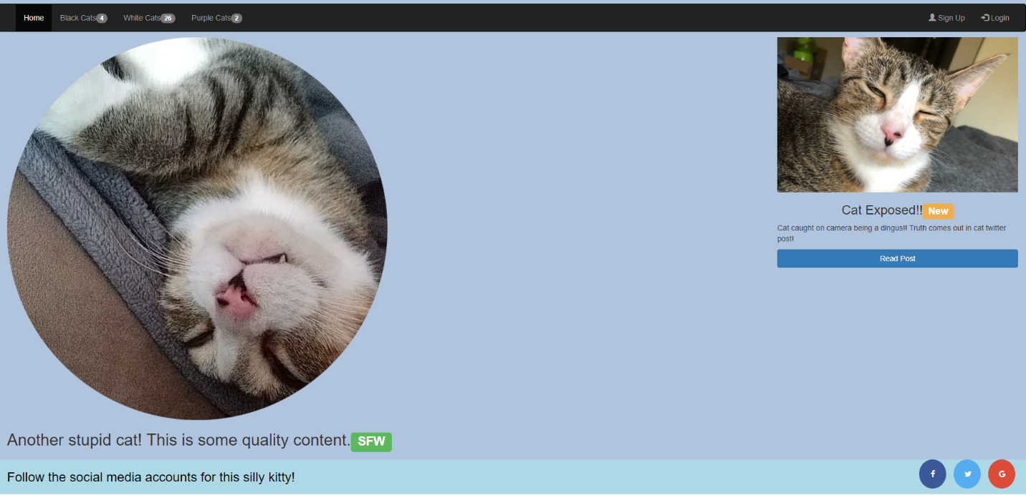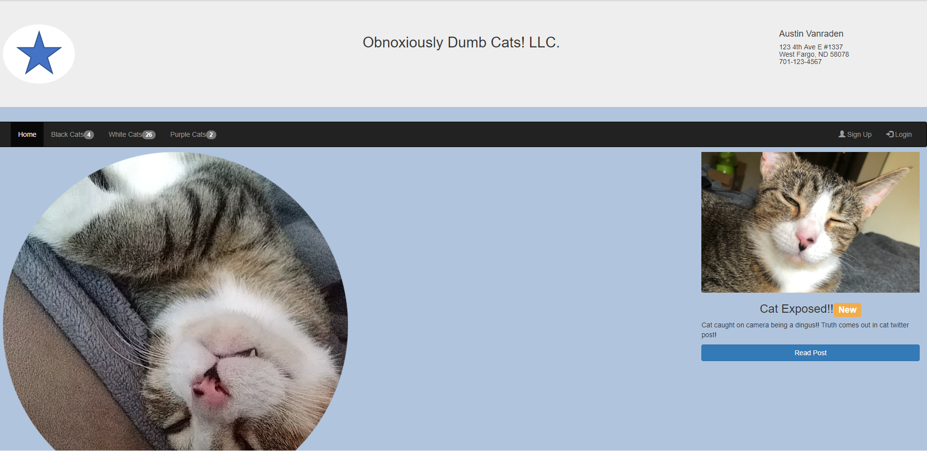

Second Page

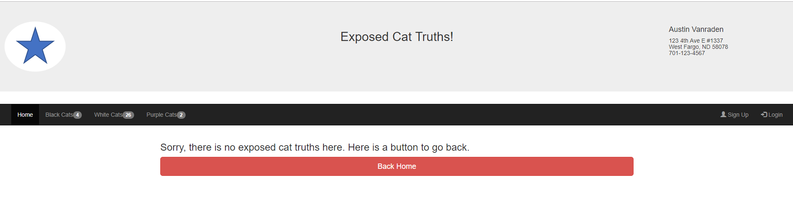

Ipad view

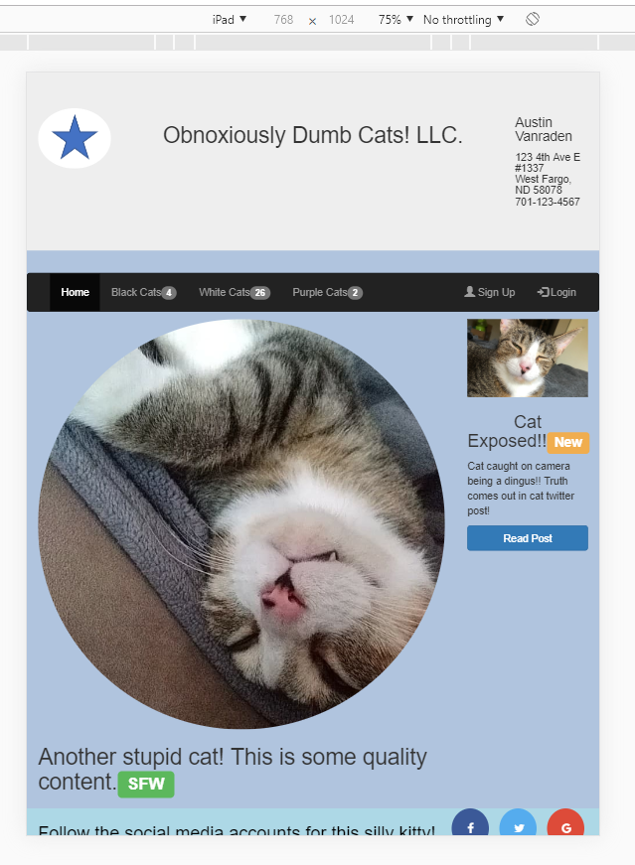

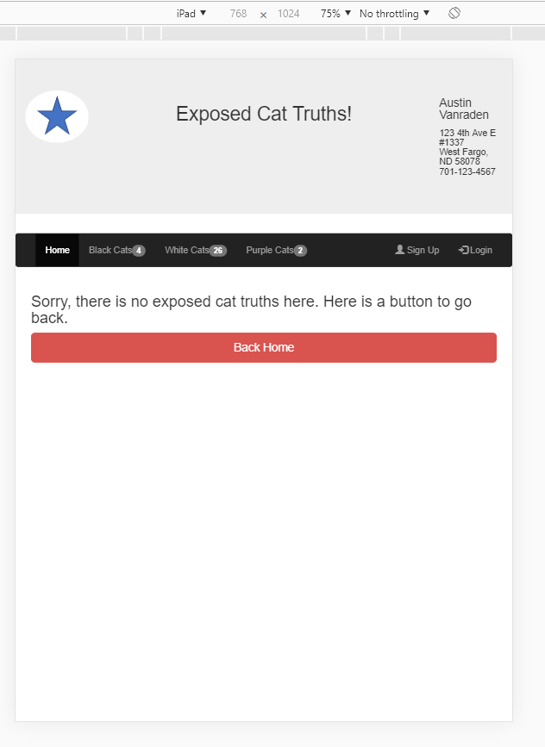

Galaxy S5 view

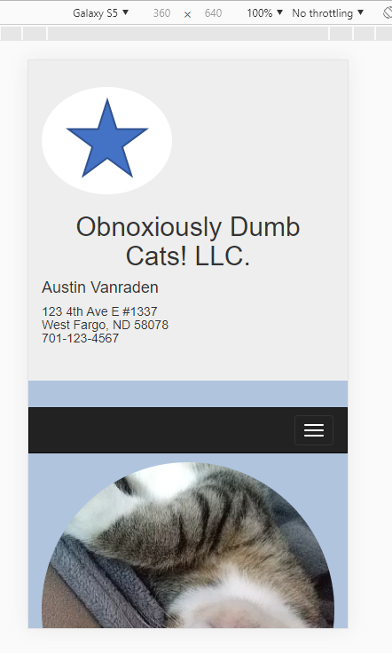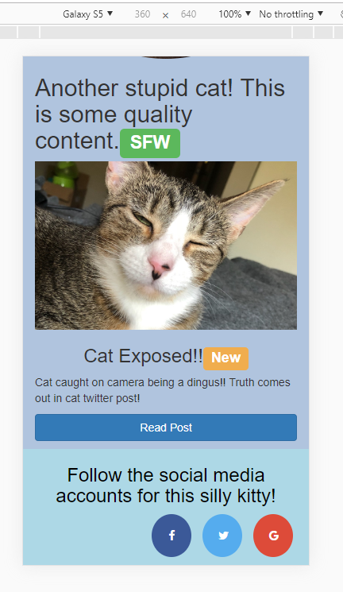

Second Page

